HTTP request headers

Content Type: application/json

Accept : application/xml

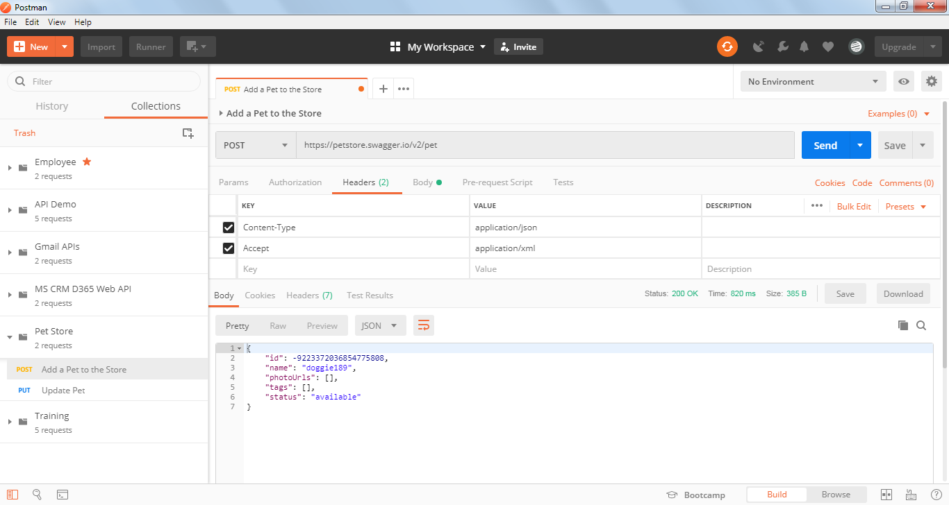

Content Type: application/xml

Accept : application/json

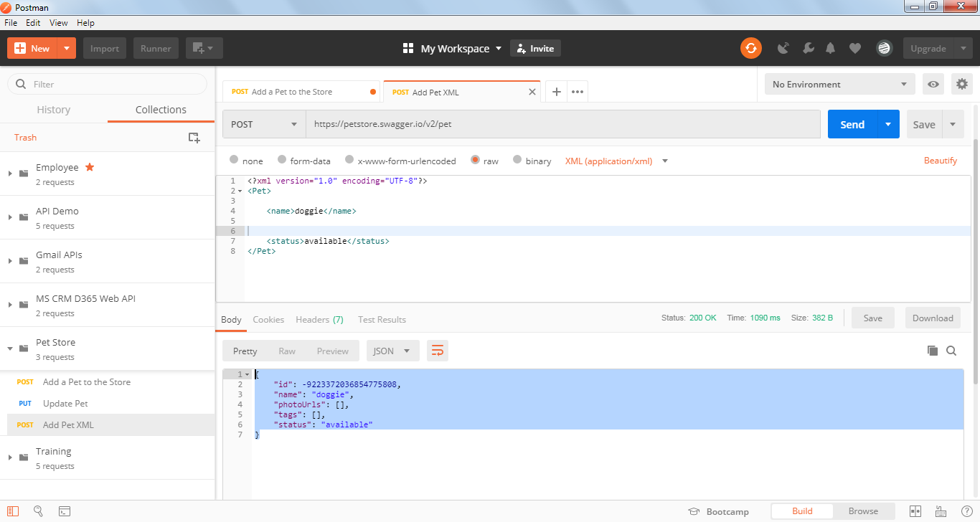

<https://petstore.swagger.io/#/pet/addPet>

Few more headers used in APIs, this will be purely based on the API documentation:

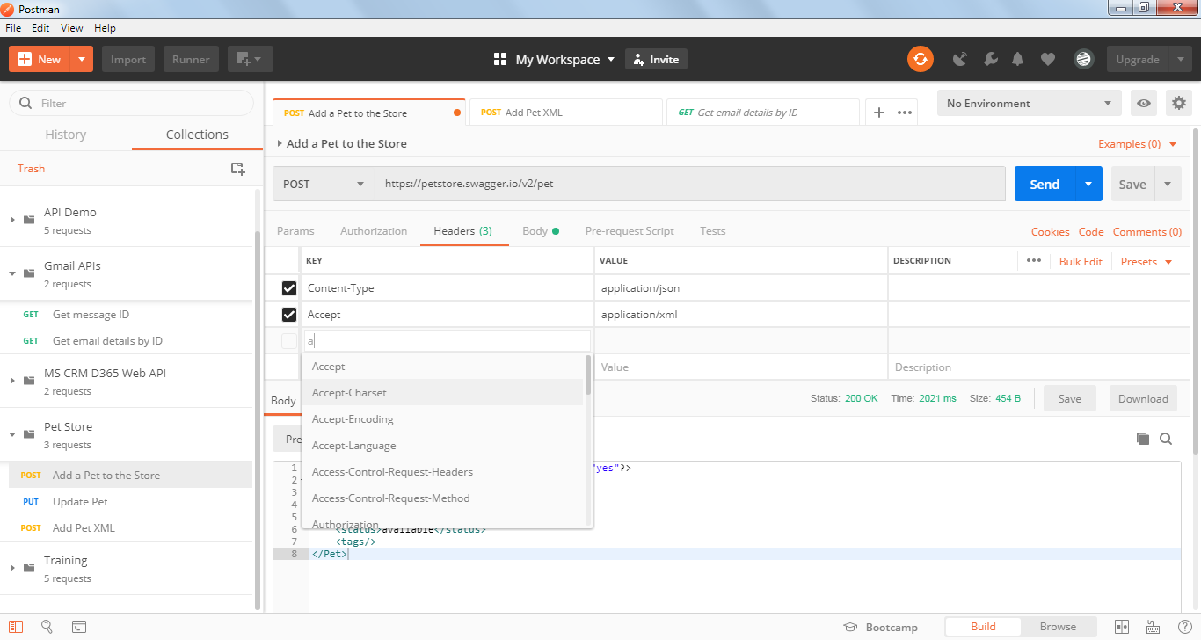

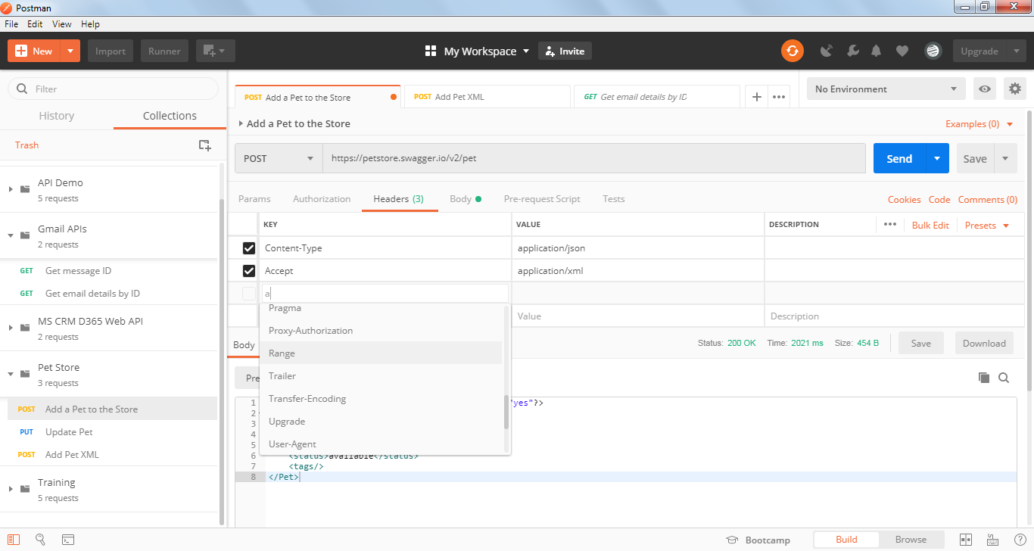

HTTP Response Headers:

Response headers are mostly for information purpose that are returned by server

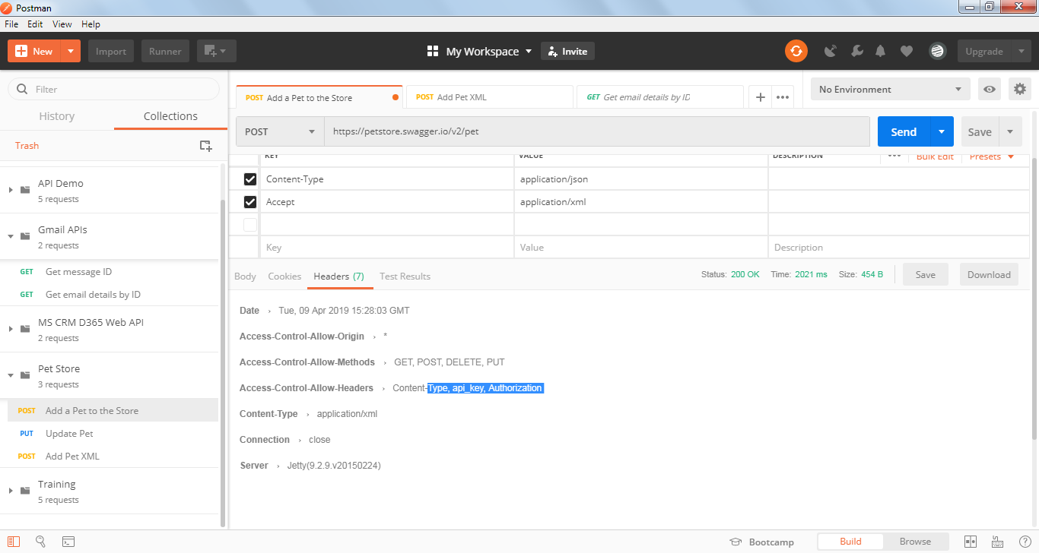

Here “Date” returns the timestamp at which the request is sent to the server

“Serve” returns details about the application server used in this example.